Inequalities and Functions Test Review
Front and Back!
Name________________________________________ TB___
- Graph and make a table for the function y=3x
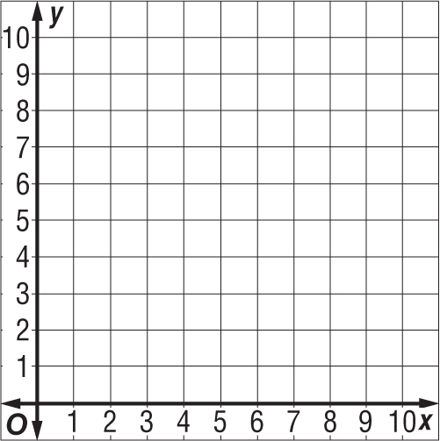
- Graph and make a table for the function y=2x+2
Input, x | 2 | 4 | 6 | 8
Output, y | 5 | 9 | 13 |  | 41

- Figure out the function rule
and fill in the missing boxes.

- Figure out the function rule
and fill in the missing boxes
Input, x | 0 | 1 | 2 |  | 20
Output, y | 0 | 3 | 6 | 24
- True or False 9+y > 14 if y=5_____
- True or False e/6 ≤ 4 if t=30 _____
- Write an inequality for the sentence: Steph made more than 5 baskets____
- Write an inequality for the sentence: Taylor wrote at least 3 songs daily___

- Graph the inequality on a number line p ≥ 1
________________________________________________
- Graph the inequality on a number line y > -6
________________________________________________
- Solve the inequality and graph the solution on a number line: d-7>10
________________________________________________

- Solve the inequality and graph the solution on a number line: 9p<54
________________________________________________

- Solve the inequality, and graph the solution on a number line: $\frac{j}{6}$ ≤ 12
_________________________________________________

